|  |  |  |  |
| --- | --- | --- | --- |
|  | Bansilal Ramnath Agarwal Charitable Trust's  Vishwakarma Institute of Information Technology  **Department of**  **Artificial Intelligence and Data Science** | | |
| Name: Siddhesh Dilip Khairnar | | | |
| Class: SY | Division: B | | Roll No: 272028 |
| Semester: IV | | Academic Year: 2022-2023 | |
| Subject Name & Code: Fundamentals of Computer Networks: ADUA22203 | | | |
| Title of Assignment: Write a program for error detection and correction for 7/8 bits ASCII codes using Hamming Codes | | | |

**ASSIGNMENT NO. 5**

**Program and Output:**

def calcRedundantBits(m):

    for i in range(m):

        if(2**i >= m + i + 1):

            return i

def postRedundantBits(data, r):

    j = 0

    k = 0

    m = len(data)

    res = ''

    for i in range(1, m + r + 1):

        if(i == 2**j):

            res = res + '0'

            j += 1

        else:

            res = res + data[-1 * k]

            k += 1

    return res[::-1]

def calcParityBits(arr, r):

    n = len(arr)

    for  i in range(r):

        val = 0

        for j in range(1, n + 1):

            if(j & (2**i) == (2**i)):

                val = val ^ int(arr[-1 * j])

        arr = arr[:n-(2**i)] + str(val) + arr[n-(2**i)+1:]

    return arr

def detectError(arr, nr):

    n = len(arr)

    res = 0

    for i in range(nr):

        val=0

        for j in range(1,n + 1):

            if(j & (2**i) == (2**i)):

                val = val ^ int(arr[-1 * j])

        res = res + val*(10**i)

    return int(str(res), 2)

data = '1011001'

m = len(data)

r = calcRedundantBits(m)

arr = postRedundantBits(data, r )

arr = calcParityBits(arr, r )

print("Data transferred is " + arr)

arr = '1111001110'

print("Error Data is " + arr)

correction = detectError(arr, r)

if(correction==0):

    print("There is no error on the recieved message.")

else:

    print("The position of error is ",len(arr)-correction+1,"from the left")

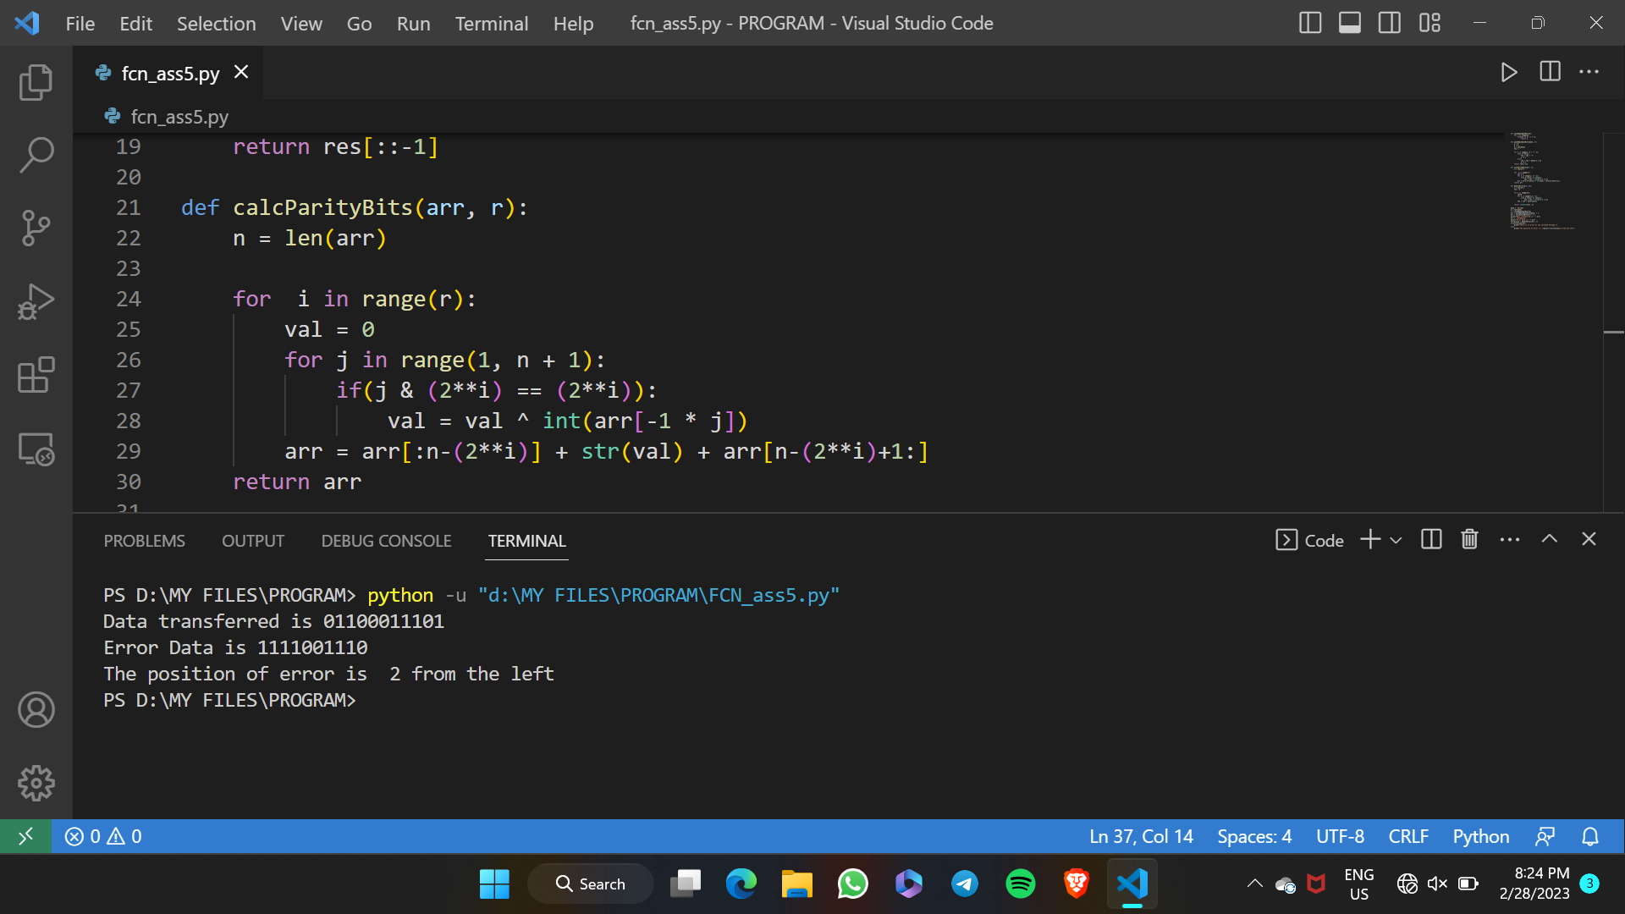

**Conclusion:** Hence, we have studied and were able to understand the concept of error detection and correction using hamming codes